Interreg North-West Europe
Application form call 4 step 2

DISCLAIMER

This document is made available for demonstration and information purposes only.
In accordance with Regulation (EU) No 2021 / 1059 of the European Parliament and of the Council, together with the decision of the Member States of the Interreg NWE Programme to use the Jems (Joint Electronic Monitoring System) for the submission of project proposals, this document cannot be used at any point in time to submit a project proposal to any of the calls published by the Interreg NWE Programme. All project submissions must be made via Jems.
The structure and content of the Application form in this template are indicative. The Interreg NWE Programme cannot be held accountable for any discrepancies between this document and the final application form which will be made available on the Jems at the opening of calls. If any such discrepancies arise, the Jems shall prevail.

PART A – Project identification

A.1 Project identification

*Asterisks indicate information required for saving.

Please be aware there may be gaps in the numbering of sections, due to the programme’s configuration of the application form for this call.

Project ID
Automatically generated according to programme rules in their monitoring system
Name of the lead partner organisation (original language and English language)
Automatically filled in from part B
Project acronym
Enter acronym here, max 25 characters
Project title
Enter title here, max 85 characters
Project duration (nr. of months)
Enter a number
Programme priority and specific objective that your project will contribute to
Programme priority*
Select from drop-down
Specific objectives*
Select from drop-down of objectives that belong to the selected programme priority (links to Part C)

A.2 Project summary

Please give a short overview of the project and describe:
- the common challenge of the programme area you are jointly tackling in your project;
- the overall objective of the project and the expected change your project will make to the current situation;
- the main outputs you will produce and those who will benefit from them;
- the approach you plan to take and why a transnational approach is needed;
- what is new/original about the project.

In English language
2000 characters

In French language

2000 characters

In German language

2000 characters

In Dutch language

2000 characters

Estimated Project Budget at Step 1
Please provide an estimation of your project budget.

Total budget | Total ERDF budget | % of total budget for investments
format: standard number – manual entry | format: standard number – manual entry | format: percent – manual entry

A.3 Project budget overview (automatically calculated)

Programme funding |  |  | Contribution |  |  |  |  | Total  budget
Funding source | Funding amount | Co-financing  rate (%) | Automatic  Public  contribution | Other public contribution | Total public contribution | Private contribution | Total contribution
ERDF
Total EU funds
Total project budget

A.4 Project outputs and result overview

Programme output indicator | Aggregated value per programme output indicator | Measure-  ment unit | Output | Output title | Output target value | Programme result indicator | Baseline | Result indicator target value | Measurement unit
From WPs | Automatically calculated | From WPs | From WPs | From WPs | From WPs | From C.5 | From C.5 | From C.5 | From C.5

PART B – Project partners

B – Partners overview

Partner number | Status | Organisation abbreviation | Partner role | NUTS | Partner total eligible budget
Automatically filled in | Automatically filled in | Automatically filled in | Automatically filled in | Automatically filled in | Automatically filled in
Automatically filled in | Automatically filled in | Automatically filled in | Automatically filled in | Automatically filled in | Automatically filled in
Automatically filled in | Automatically filled in | Automatically filled in | Automatically filled in | Automatically filled in | Automatically filled in

B.1 Project partner 1

B.1.1 Partner identity

Partner role |  | List: lead partner, project partner
Abbreviated name of organisation* |  | Enter here  Max 15 characters
Name of organisation in original language |  | Enter here  Max 85 characters
Name of organisation in English |  | If existing, using the official translation  Max 85 characters
Department /unit / division |  | If applicable, enter here  Max 250 characters

Legal and financial information
Type of partner
Drop-down pre-defined list (see Annex 1 – Type of partner and target group classification)
Partner size
Drop-down pre-defined list
Legal status*
Drop-down (public* / private*)
Sector of activity at NACE group level. Please refer to the statistical classification of economic activities NACE Rav. 2 (2008) available via the [Eurostat website].
Drop-down pre-defined list. This field is only for state aid relevant activities.
VAT number (or other identifier)
50 characters
If VAT nr is not available, some other organisation identifier should be used.
Other identifier number
50 characters
Other identifier description
100 characters
PIC (from EC Participant Register)

Advance Payment

Partners with micro-enterprise or ‘micro’ NGO status can request an advance payment. This status applies to enterprises or non-governmental organisations employing fewer than 10 people and whose annual turnover and/or annual balance sheet total does not exceed EUR 2 million.
The advance payment is limited to either €50,000 ERDF at partner level or 50% of the partner’s ERDF budget, whichever is the lowest.
Please refer to section 5 of the Programme manual for more information.

The organisation applies for an advance payment tick box

B.1.2 Partner address

Partner main address
Information about NUTS codes and how to identify your region: https://ec.europa.eu/eurostat/web/nuts/background

Country (Nuts 0)
Drop-down list
Region (NUTS 2)
Drop-down list
Region (NUTS 3)
Drop-down list
Street
Enter text, max 50 characters
House number
Enter text, max 20 characters
Postal code
Enter text, max 20 characters
City
Enter text, max 50 characters
Homepage
Enter text, max 250 characters

Address of department / unit / division (if applicable)

Country (Nuts 0)
Drop-down list
Region (NUTS 2)
Drop-down list
Region (NUTS 3)
Drop-down list
Street
Enter text, max 50 characters
House number
Enter text, max 20 characters
Postal code
Enter text, max 20 characters
City
Enter text, max 50 characters

B.1.4 Legal representative

Title |  | First name |  | Last name
Enter text, max 25 characters |  | Enter text, max 50 characters |  | Enter text, max 50 characters

B.1.5 Contact person

Title |  | First name |  | Last name
Enter text, max 25 characters |  | Enter text, max 50 characters |  | Enter text, max 50 characters

E-mail address |  | Telephone
Enter text, max 255 characters |  | Enter text, max 25 characters

B.1.6 Partner motivation and contribution

Which of the organisation’s thematic competences and experiences are relevant for the project?
Enter text here
Recommended in Step 1: 500 characters
Max 1000 characters

What is the role (contribution and main activities) of your organisation in the project?
Enter text here
Recommended in Step 1: 500 characters
2000 characters

Partner budget overview

Partner | Automatically filled in
Staff costs | Automatically filled in
Office and administrative costs | Automatically filled in
Travel and accommodation | Automatically filled in
External expertise and services | Automatically filled in
Equipment | Automatically filled in
Infrastructure and works | Automatically filled in
Other costs | Automatically filled in
Lump sum | Automatically filled in
Total | Automatically filled in

Partner budget options

Office and administrative costs flat rate based on direct staff costs tick box
15% of Staff costs (fixed rate)
This option cannot be combined with the Office and administrative costs flat rate based on direct cost
Travel and accommodation flat rate tick box
6% of Staff costs
All partners should set this flat rate at 6% except Irish partners (8%)
Other costs Flat Rate tick box
40% of Staff costs (fixed rate)
This option cannot be combined with any other flat rate option

Partner budget
All amounts in the budget are rounded down to 2 digits after the comma.

Staff costs
Staff function | Unit type | No. of units | Price per unit | Total
Enter text here  Max 255 characters | Enter text here | Enter a number here | Enter a number here | Automatically generated

External expertise and services
Description | Award procedures | Investment | Unit type | No. of units | Price per unit | Total
Enter text here  Max 255 characters | Enter text here  Max 250 characters | Drop-down list | Enter text here  Max 100 characters | Enter a number here | Enter a number here | Automatically generated

Equipment
Description | Award procedures | Investment | Unit type | No. of units | Price per unit | Total
Enter text here  Max 255 characters | Enter text here  Max 250 characters | Drop-down list | Enter text here  Max 100 characters | Enter a number here | Enter a number here | Automatically generated

Infrastructure and works
Description | Award procedures | Investment | Unit type | No. of units | Price per unit | Total
Enter text here  Max 255 characters | Enter text here  Max 250 characters | Drop-down list | Enter text here  Max 100 characters | Enter a number here | Enter a number here | Automatically generated

Partner lump sums (assisgned in section E.1 – Project lump sums)
Programme lump sum | Lump sum cost | Partner share of lump sum cost
Total partner lump sums | Automatically generated | Automatically generated

Co-financing
Source | Amount |  | Percentage
Enter text here
Enter text here
Etc.
Partner total eligible budget automatically filled in
Origin of partner contribution
Source of contribution Legal status of contribution* Amount % of total
partner budget
Sub-total public contribution
Sub-total automatic public
contribution
Sub-total private contribution
Total automatically filled in

State aid criteria self-check

Criterium I: Is the partner involved in economic activities within the project?
Please consider questions below, answer Yes/No and briefly justify.
State Aid question | Answer | Justification
- Will the partner implement activities and/or offer goods/services for which a market exists? | Yes/No | Enter text here, max 1000 characters
- Are there activities/goods/services that could have been undertaken by an operator with the view of making profit (even if this is not the partner’s intention)? | Yes/No | Enter text here, max 1000 characters

Criterium II: Does the partner receive an undue advantage in the framework of the project?
Please consider questions below, answer Yes/No and briefly justify.
State Aid question | Answer | Justification
- Does the project applicant plan to carry out the economic activities on its own i.e. not to select an external service provider via public procurement procedures for example? | Yes/No | Enter text here, max 1000 characters
- Will the project applicant, any other operator not included in the project as a project partner or the target audience gain any benefits from its project economic activities, not received in the normal course of business (i.e. not received in the absence of funding granted through the project)? | Yes/No | Enter text here2, max 1000 characters

State aid relevant activities (select from drop-down menu based on C.4 entries) |  | Multiply choice selection of project partner's WPs activities numbers from C.4. work plan
 | State aid regime (to be filled in ONLY after project selection) | Drop down list (GBER article 20/ GBER article 20a / de minimis)

Associated organisations

Name of organisation in original language |  | Enter here  Max 100 characters
Name of organisation in English |  | If existing, using the official translation  Max 100 characters
Partner |  | Link to a partner who is supported by this associated organization  Drop-down list

Country (Nuts 0)
Drop-down list
Region (NUTS 2)
Drop-down list
Region (NUTS 3)
Drop-down list
Street
Enter text, max 50 characters
House number
Enter text, max 20 characters
Postal code
Enter text, max 20 characters
City
Enter text, max 50 characters

Legal representative

Title |  | First name |  | Last name
Enter here  Max 25 characters |  | Enter here  Max 50 characters |  | Enter here  Max 50 characters

Contact person

Title |  | First name |  |  |  | Last name
Enter here  Max 25 characters |  | Enter here  Max 50 characters |  |  |  | Enter here  Max 50 characters
E-mail address |  |  |  | Telephone
Enter here  Max 255 characters |  |  |  | Enter here  Max 25 characters

Please describe the role of the associated organisation in the project.
Enter text here
Max 2000 characters

B.2 Project partner 2 […]

All sections from B.1 repeat

PART C – Project description

C.1 Project overall objective

Below, you can see the Programme priority specific objective your project will contribute to (chosen in section A.1.).

Programme priority specific objective | Automatically filled in

Project overall objective

Now think about your main objective – what do you aim to achieve by the end of your project? Remember your project needs to contribute to the programme’s objective.

Your objective should:
- be realistic and achievable by the end of the project, or shortly after;
- specify who needs project results and in which territory;
- be measurable – indicate the change you are aiming for.

Project overall objective | Programme priority specific objective
Enter text here, max 500 characters | Automatically inserted once it is selected in section A.1

C1.a - Project specific objectives
In Step 1: List your foreseen project specific objectives (up to three)
In Step 2: List your project specific objectives (up to three)
First project specific objective (Recommended in Step 1: Max 200 characters)
Max 500 characters per specific objective
Second project specific objective (Recommended in Step 1: Max 200 characters)
Max 500 characters per specific objective
Third project specific objective (Recommended in Step 1: Max 200 characters)
Max 500 characters per specific objective

C.2 Project relevance and context

C.2.1 What are the common territorial challenge(s) that will be tackled by the project?
Please describe the territorial challenges and opportunities your project addresses in the NWE area. Why is transnational cooperation needed to address these challenges and opportunities?
Enter text here, max 2000 characters
C.2.2.a - How does the project tackle identified common challenges and/or opportunities?
Please describe if your project activities will develop and test new approaches; and/or if they will adapt and implement existing approaches for further uptake.
Enter text here, max 2000 characters

C2.2.b – What is new about the approach the project takes?
Please describe how your approach is different from the current situation or existing practice. Explain what you expect to change in the sector/Programme area/participating countries.
Enter text here, max 2000 characters

C.2.4 Who will benefit from your project?
In the first column of each row, please select one of the pre-defined target groups from the drop-down list. In the second column explain in more detail exactly who will benefit from your project. For example, if you choose the category education, you need to explain which specific schools or groups of schools and in which territory.

Target group | Specification
Select from drop-down | Enter text, max 500 characters
Select from drop-down | Enter text, max 500 characters
Select from drop-down | Enter text, max 500 characters
…

C.2.6 Which synergies with past or current EU and other projects or initiatives will the project make use of?
Synergies
Enter title, max 2000 characters | Enter text here, max 2000 characters
Enter title, max 2000 characters | Enter text here, max 2000 characters

C.2.7 How does the project build on available knowledge?
Please describe what the project draws on e.g., from EU and/or other projects, and other available knowledge, and how the project capitalises on this knowledge.
Enter text here, max 1000 characters

C.3 Project partnership

Describe the structure of your partnership and explain why these partners are needed to implement the project and to achieve project objectives.
In Step 1: Please describe which types of organisations are already included in step 1 as partners, and which ones will be further added in step 2, if any.
In Step 2: Please describe the final partnership composition, partners? roles, and how they will interact and cooperate.

Enter text here, max 4000 characters

C.4 Project work plan

A maximum of 3 work packages is allowed in every project work plan in a regular call. In the case of a small-scale projects call, maximum 1 work package is allowed. Please be aware that you will not be able to submit your AF if you are above those limits.

C.4.1 Work package 1

Work package number | Automatically generated
Work package title | Enter the title here, max 100 characters

Project Specific Objectives

Your objectives should be:
- realistic and achievable by the end of the project;
- specific (who needs project outputs delivered in this work package, and in which territory);
- measurable – indicate the change you are aiming for.

Define one project specific objective that will be achieved when all activities in this work package are implemented and outputs delivered.

Project specific objective | Enter project specific objective here, max 250 characters
Think about the communication objective that will contribute to the achievement of the specific objective.
Communication objectives aim at changes in a target audience's behaviour, knowledge or belief.
Communication objective(s) and target audience | Communication objective and target audience  Max 500 characters

Work package summary
Please provide a summary of your work package.
Enter text here, max 1000 characters

Investment

Fields with questions about the investment:
- Investment number (automatic)
- Investment title (Max 50 characters)
- Expected delivery period (drop-down)
- Justification
- Please explain why this investment is needed. (Max 2000 characters)
- Please clearly describe the cross-border/transnational relevance of the investment. (Max 2000 characters)
- Please describe who is benefiting (e.g., partners, regions, target groups, etc.) from this investment, and in what way. (Max 2000 characters)
- In the case of pilot investment, please clarify which problem it tackles, which findings you expect from it, how it can be replicated, and how the experience coming from it will be used for the benefit of the programme area. (Max 2000 characters)
- Location of the physical investment
- Please describe, if possible, a specific address where the investment will be located
- Drop-down list (NUTS3 codes + whole programme area)
- Risks associated with the investment
- Describe the risks associated with the investment, go/no-go decisions, etc. (if any) (Max 2000 characters)
- Investment documentation
- Please list all technical requirements and permissions (e.g., building permits) required for the investment according to the respective national legislation. If these are already available, attach them to this application form, otherwise indicate when you expect them to be available. (Max 2000 characters)
- Is your investment considered an investment in infrastructure (i.e., that has an expected lifespan of at least five years)? If yes, then an assessment of the expected impacts that climate change may have on your infrastructure (e.g., flooding, heat-stress, wildfires, etc.) must be carried out prior to applying. Should it be necessary, you must be ready to submit this documentation to the relevant programme bodies. Please indicate here the outcomes of this assessment. Describe how you will take them into account as part of your project's design. Short to medium term (10-15 years) impacts should be considered. (Max 2000 characters)
- Ownership
- Who owns the site where the investment is located? (Max 500 characters)
- Who will retain ownership of the investment at the end of the project? (Max 500 characters)
- Who will take care of the maintenance of the investment? How will this be done? (Max 2000 characters)

List of activities

Please describe the activities by which the project achieves the project specific objective and related communication objective(s).

Each Work package must include at least one communication activity and deliverable which will allow for the communication objective(s) to be reached.

If relevant, the Work package should also include a Long-Term Effects activity and deliverable which will ensure the long-term effects of project outputs and results.

Ac Nr. | Activity title | Start period | End period | Activity description
A 1.1 | Enter text  Max 200 characters | Select the period from drop-down | Select the period from drop-down | Enter text  Max 1000 characters
A 1.2 | Enter text  Max 200 characters | Select the period from drop-down | Select the period from drop-down | Enter text  Max 1000 characters
A 1.3 | Enter text  Max 200 characters | Select the period from drop-down | Select the period from drop-down | Enter text  Max 1000 characters
A 1.4 | Enter text  Max 200 characters | Select the period from drop-down | Select the period from drop-down | Enter text  Max 1000 characters
A 1.5 | Enter text  Max 200 characters | Select the period from drop-down | Select the period from drop-down | Enter text  Max 1000 characters

Deliverables
Add deliverables to your activity – see programme rules.

Del Nr. | Deliverable title | Delivery period | Description
D 1.1.1 | Enter text here  Max 100 characters | Select the period from drop-down | Enter text here  300 characters
Outputs

Based on the activities you need to implement to achieve the specific objective in this work package, please list below the outputs that will be delivered during the implementation.

Regarding the drop-down list of ‘Programme output indicators’:
For every project output you define, you must choose one Programme output indicator to contribute to from the drop-down list and quantify your contribution.
Overall, as a project you must contribute to a minimum of 2 out of the 4 following output indicators.
Important: Please note that if you choose output indicator O.2 then you must also choose output indicator O.3 AND one more output indicator for a total of 3 out of 4 (e.g., O.2, O.3 and O.4).
- O.1: Strategies and action plans jointly developed
- O.2: Pilot actions developed jointly and implemented in projects
- O.3: Jointly developed solutions
- O.4: Participations in joint training schemes

 | Output 1 | Output 2 | Output 3 | Etc.
Output title | Enter text | Enter text | Enter text | Enter text
Programme output indicator | Choose from the drop-down list | Choose from the drop-down list | Choose from the drop-down list | Choose from the drop-down list
Measurement unit | Automatically retrieved from programme data | Automatically retrieved from programme data | Automatically retrieved from programme data | Automatically retrieved from programme data
Delivery period | Enter the number | Enter the number | Enter the number | Enter the number
Output description | Dropdown | Dropdown | Dropdown | Dropdown

C.4.2 Work package 2
Repeat of the whole section C.4.1

C.4.3 Work package 3

Repeat of the whole section C.4.1

C.5 Project results

What do you expect to change because of the activities you plan to implement and the outputs you plan to deliver? Please take a look at the programme result indicators and select those that you will contribute to.

Regarding the drop-down list of ‘Programme result indicators’:
For every project result you define, you must choose one Programme result indicator to contribute to from the drop-down list and quantify your contribution.
Overall, as a project, you must contribute to a minimum of 2 out of the 3 following result indicators.
Make sure they correspond to the output indicators you have chosen (applicable only in Step 2):
- R.1: Joint strategies and action plans taken up by organisations
- R.2: Solutions taken up or up scaled by organisations
- R.3: Completion of joint training schemes

In addition to the 2 chosen from the list above, please note R.4 ‘Organisations with increased institutional capacity due to their participation in cooperation activities across borders’ must be contributed to by default by all projects.

 | Result 1 | Result 2 | Result 3 | Etc.
Programme result indicator | Choose from the drop-down list | Choose from the drop-down list | Choose from the drop-down list | Choose from the drop-down list
Measurement unit | Automatic | Automatic | Automatic | Automatic
Result indicator baseline | Automatically retrieved from programme data | Automatically retrieved from programme data | Automatically retrieved from programme data | Automatically retrieved from programme data
Result indicator target value | Enter the number | Enter the number | Enter the number | Enter the number
Delivery period | Dropdown | Dropdown | Dropdown | Dropdown
Result description | Describe in more detail the change expected  Recommended in step 1: 500 characters  (Max 1000 characters) | Describe in more detail the change expected  Recommended in step 1: 500 characters  (Max 1000 characters) | Describe in more detail the change expected  Recommended in step 1: 500 characters  (Max 1000 characters) | Describe in more detail the change expected  Recommended in step 1: 500 characters  (Max 1000 characters)

C.6 Time plan
Only applicable in step 2

Work packages and activities | Period 1 | Period 2 | Period 3 | Period 4 | Period 5 | Period 6
WP 1: Title
A 1.1 title
A 1.2 title |  |  | Deliverable  1.2.1
A 1.3 title
A 1.4 title
OI 1.1
OI 1.2
WP 2: Title
A 2.1 title
A 2.2 title
A 2.3 title
A 2.4 title
OI 2.1
WP 3: Title
Etc.
Result indicator
RI 1
RI 2

C.7 Project management

In addition to the thematic work you will do in your project, you will need time and resources for coordination and internal communication. Please describe below how you plan to organise yourself to ensure the project work runs smoothly.

C.7.1 How will you coordinate your project?
Who will be responsible for coordination? Will you have any other management structures (e.g., thematic groups, WP managers)? How will the internal communication work?
Enter text here, max 2000 characters
C.7.2 Which measures will you take to ensure quality in your project?
Quality management: How will you ensure project quality (quality control measures)?
Risk management: List the three main risks of your project and potential mitigation measures.
Enter text here, max 3000 characters
C.7.3 What will be the general approach you will follow to communicate about your project?
Who will coordinate project communication and how will he/she ensure the involvement of all partners? How will the communication function contribute to uptake and scale up of your project results? Please note that all communication activities, including a compulsory communication strategy as first deliverable, should be included in the work packages as an integral part of your project. There is no need to repeat this information here.
Enter text here, max 3000 characters
C.7.4 How do you foresee the financial management of the project and reporting procedures for activities and budget (within the partnership and towards the programme)?
Define responsibilities, deadlines in financial flows, reporting flows, project related transfers, reclaims, etc.
Enter text here, max 3000 characters
C.7.5 Cooperation criteria
Please select all cooperation criteria that apply to your project and describe how you will fulfil them.
Cooperation criteria |  | Description
Joint Development* |  | Enter text here, max 250 characters
Joint Implementation* |  | Enter text here, max 250 characters
Joint Staffing |  | Enter text here, max 250 characters
Joint Financing |  | Enter text here, max 250 characters

C.7.6 Horizontal principles
Please indicate which type of contribution to horizontal principles applies to the project and justify your choice.
Horizontal principles | Type of contribution | Description of the contribution
Sustainable development | Drop-down list: positive effects, neutral, negative effects | Enter text here  Max 250 characters
Equal opportunities and non-discrimination | Drop-down list: positive effects, neutral, negative effects | Enter text here  Max 250 characters
Equality between men and women | Drop-down list: positive effects, neutral, negative effects | Enter text here  Max 250 characters

C.8 Long-term plans

As a programme, we would like to support projects that have a long-lasting effect in the territory and those who will benefit from them. Please describe below what you will do to ensure this.

C.8.1 Ownership
Please describe who will ensure the financial and institutional support for the outputs/deliverables developed by the project (e.g., tools), and explain how these outputs/deliverables will be integrated in the work of the institutions.
Enter text here, max 1000 characters
C.8.2 Durability
Some outputs/deliverables should be used by relevant groups (project partners or others) after the project's lifetime, in order to have a lasting effect on the territory and the population. For example, new practices in urban transport need to be used by local authorities to have cleaner air in the city, and the whole population will benefit from this. Please describe how your outputs/deliverables will be used after the project ends and by whom.
Enter text here, max 1000 characters
AF annexes: attachments

Only explicitly allowed documents should be provided in attachment (see Programme Manual chapter 4) at step 1 and step 2.

Budget tables

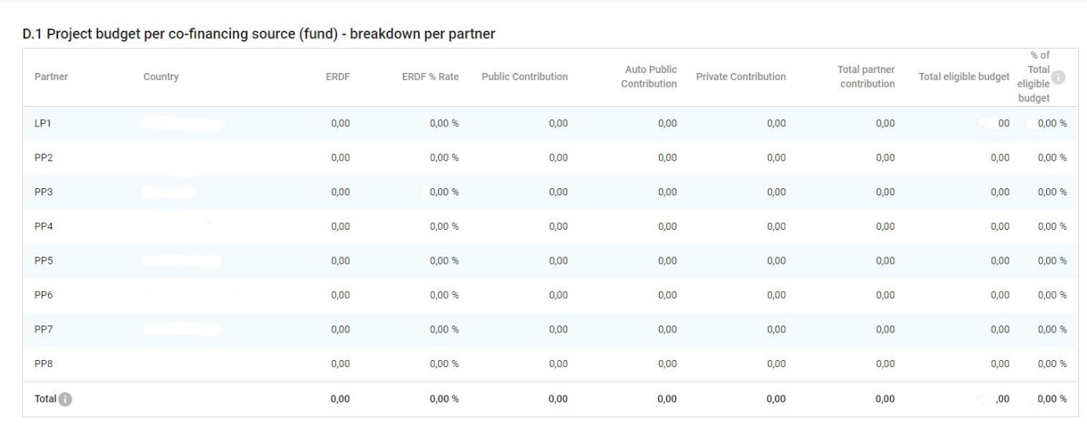
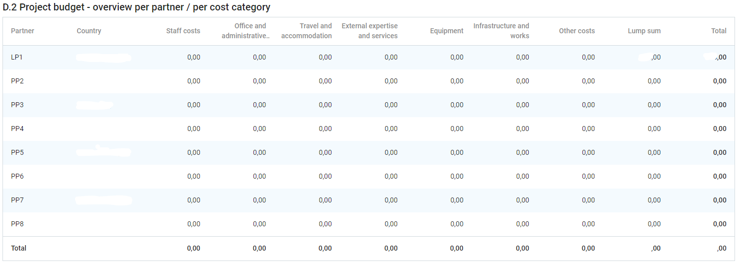

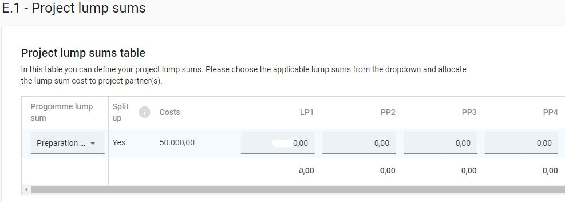

ANNEX 1 - Classification of type of partners and target groups

Nr | Main categories | Examples | Measurement unit
1 | Local public authority | municipality, etc. | [number of organisations]
2 | Regional public authority | regional council, etc. | [number of organisations]
3 | National public authority | ministry, etc. | [number of organisations]
4 | Sectoral agency | local or regional development agency, environmental agency, energy agency, employment agency, etc. | [number of organisations]
5 | Infrastructure and (public) service provider | public transport, utility company (water supply, electricity supply, sewage, gas, waste collection, etc.), airport, port, railway, etc. | [number of organisations]
6 | Interest groups including NGOs | international organisation, trade union, foundation, charity, voluntary association, club, etc. | [number of organisations]
7 | Higher education and research organisations | university faculty, college, research institution, RTD facility, research cluster, etc. | [number of organisations]
8 | Education/training centre and school | primary, secondary, pre-school, vocational training, etc. | [number of organisations]
9 | Enterprise, except SME |  | [number of enterprises]
10 | SME | micro, small, medium | [number of SME]
11 | Business support organisation | chamber of commerce, chamber of trade and crafts, business incubator or innovation centre, business clusters, etc. | [number of organisations]
12 | EGTC |  | [number of organisations]
13 | International organisation, EEIG | under national law, under international law | [number of organisations]
14 | General public |  | [number of people]
15 | Hospitals and medical centres |  | [number of organisations]
16 | Other

Relevant only for target groups.

